**Induction for contractors**

SITE: Kidwelly Quay DATE: 02/02/22

**NAME AND CONTACT DETAILS OF ECOLOGIST: Amanda Evans 07967 598808**

Dormice may be present on this site. The dormouse is a European Protected Species. It is illegal to deliberately capture, injure or kill dormice or damage or destroy a resting place or breeding site. Dormice can be affected by disturbance, e.g. noise and light, woodland and hedgerow management and scrub removal. Before work commences, the work area will be checked for signs of dormice, but *you* should also be aware of the possibility of finding a dormouse or nest whilst working.

**IF YOU THINK YOU HAVE FOUND A NEST, STOP WORK AND REPORT IT TO THE ECOLOGIST IMMEDIATELY.**

During summer and autumn, dormice use nests which they weave from honeysuckle bark, dried purple moor grass or leaves. These are often found on the edge of scrub patches, where bramble meets tussocky grassland. Areas of vegetation to be removed will be checked for signs of dormice or their nests, before work commences.

**Clearance should be carried out by starting from the most open area (e.g. the centre of a field or footpath edge) and working back to denser areas of vegetation (e.g. hedge or woodland), to allow any dormice present to move safely into another area of habitat.**

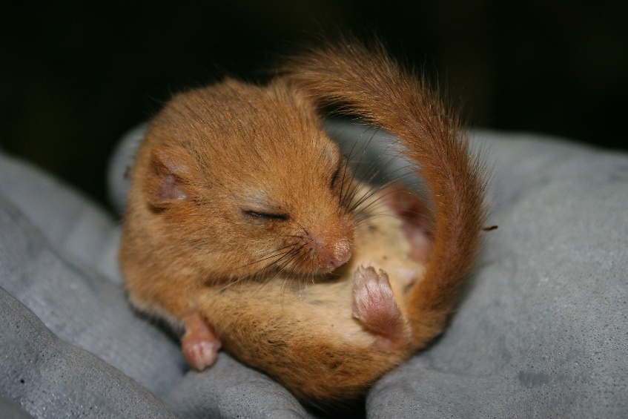[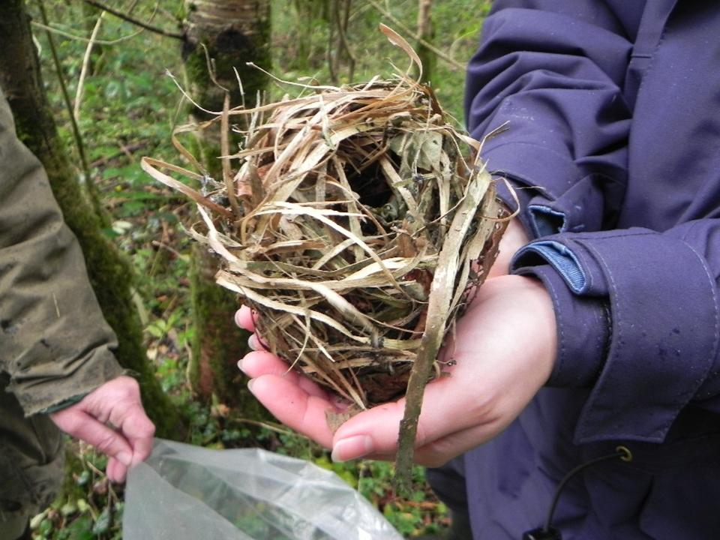](http://www.google.co.uk/url?sa=i&rct=j&q=&esrc=s&source=images&cd=&cad=rja&uact=8&ved=0ahUKEwidr8WB7NzQAhWVHsAKHQNjCkkQjRwIBw&url=http://www.denbighshirecountryside.org.uk/hazeldormouse/&psig=AFQjCNHIwl8YWQ122Xf_TqHFF-5hOApGMQ&ust=1481020083449740) 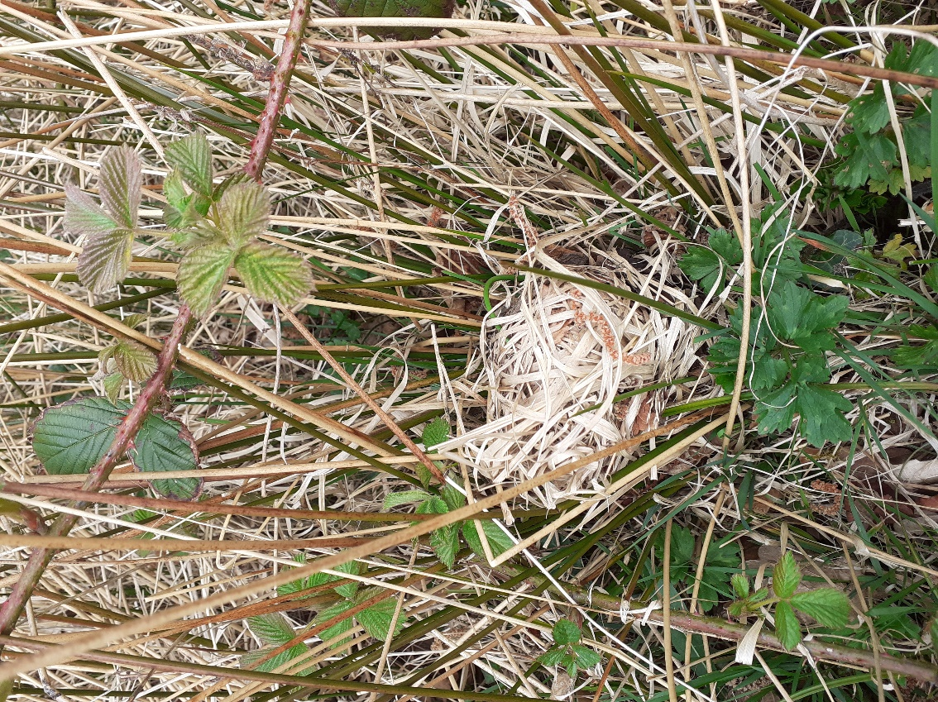

During winter, or in late autumn/ early spring when night-time temperatures are below freezing for several consecutive nights, dormice will be hibernating, although they can temporarily come out of hibernation during milder periods. Hibernation nests are constructed of grass and leaves and will be just below the ground surface. Checks for hibernation nests will be carried out before work starts.

**As a precaution, in cold weather, vegetation must be cut no lower than 30cm to avoid disturbing any nests which may be present.**

 